Exhibit 12: Hybrid Identity Anomaly Detection – LANL Authentication Logs

Petitioner: Samuel Gbli Tetteh
NIW Proposed Endeavor Pathway 1: Context‑aware anomaly detection models for hybrid identity systems

1. Project Summary

This project implements an unsupervised anomaly detection system that analyzes authentication logs to flag suspicious user behavior in a hybrid (cloud + on‑premises) identity environment. It uses the publicly available LANL Comprehensive Cyber Security Events dataset and trains an Isolation Forest model to identify unusual login patterns—exactly the type of context‑aware detection described in my proposed endeavor’s first research pathway.

---

2. Alignment with Proposed Endeavor

In my personal statement, I committed to developing context‑aware anomaly detection models specifically tailored for hybrid identity systems. This prototype directly addresses that goal:

- It ingests real‑world authentication logs (timestamp, user, source PC, logon type).
- It engineers context features: time of day, day of week, weekend flag, user activity frequency, and PC diversity.
- It deploys an unsupervised Isolation Forest to detect deviations from normal behavior without labeled attack data.
- It identifies outliers that could represent credential theft, lateral movement, or misconfigurations.

The project proves my ability to build ML‑driven security analytics for hybrid identity environments using open data and tools.

---

3. Technical Implementation

3.1 Dataset
- Source: LANL Comprehensive, Multi‑source Cyber Security Events (public).
- Size: 2,000,000 authentication events, 7,399 unique users, 4,157 unique source PCs.
- Processing: Data was processed using Polars (a high‑performance DataFrame library) to handle the larger volume efficiently, mirroring the scalability required in real hybrid identity environments.
- Features engineered: Hour, day of week, weekend indicator, hourly login count per user, unique PC count per user, logon type encoding.

3.2 Model
- Algorithm: Isolation Forest (contamination=0.01, 100 estimators).
- Approach: Features were standardized; the model was trained unsupervised to assign anomaly scores.

3.3 Key Results
=============================================
NOTEBOOK 03b — SUMMARY (Polars)
=============================================
Total auth events : 2,000,000
Anomalies detected : 17,399 (0.87%)
Unique users : 7,399
Unique source PCs : 4,157
Top anomalous user : ANONYMOUS LOGON@C586
=============================================

Figure: Summary output from the completed notebook.

3.4 Reproducibility
All code, data preprocessing, and the saved model/scaler are publicly available in my GitHub repository:
[Insert your GitHub repo URL here] - https://github.com/samuelgtetteh/Samuel_Tetteh_Dev-V2_Restart

4. Visual Evidence

4.1 Notebook Summary Output
![Summary metrics](Exhibit12a_summary.png)
Caption: Output of the summary cell showing dataset size, anomaly count, and top anomalous user.

4.2 Anomaly Visualization (if available)
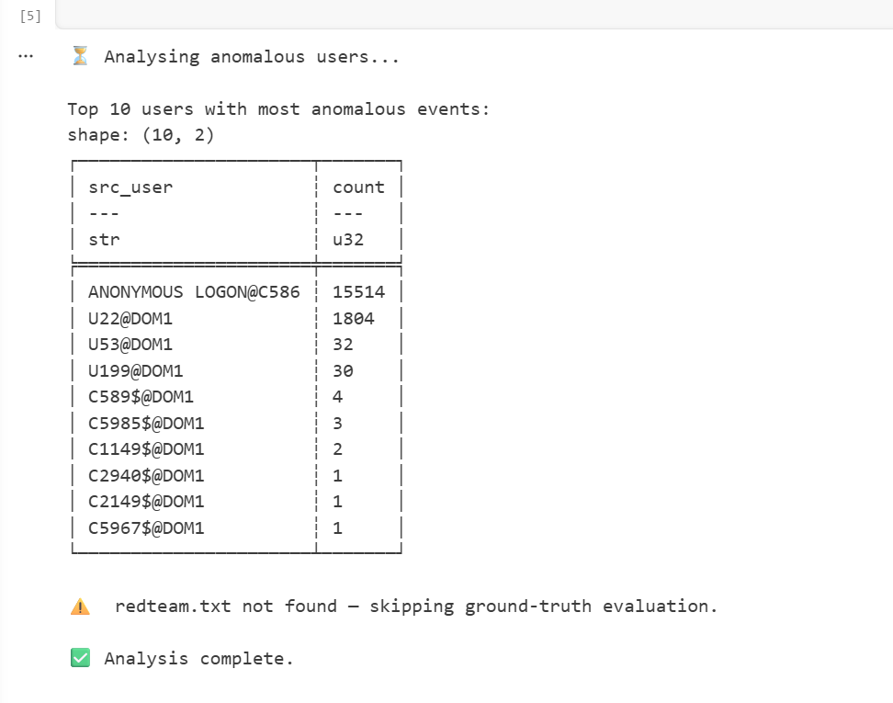
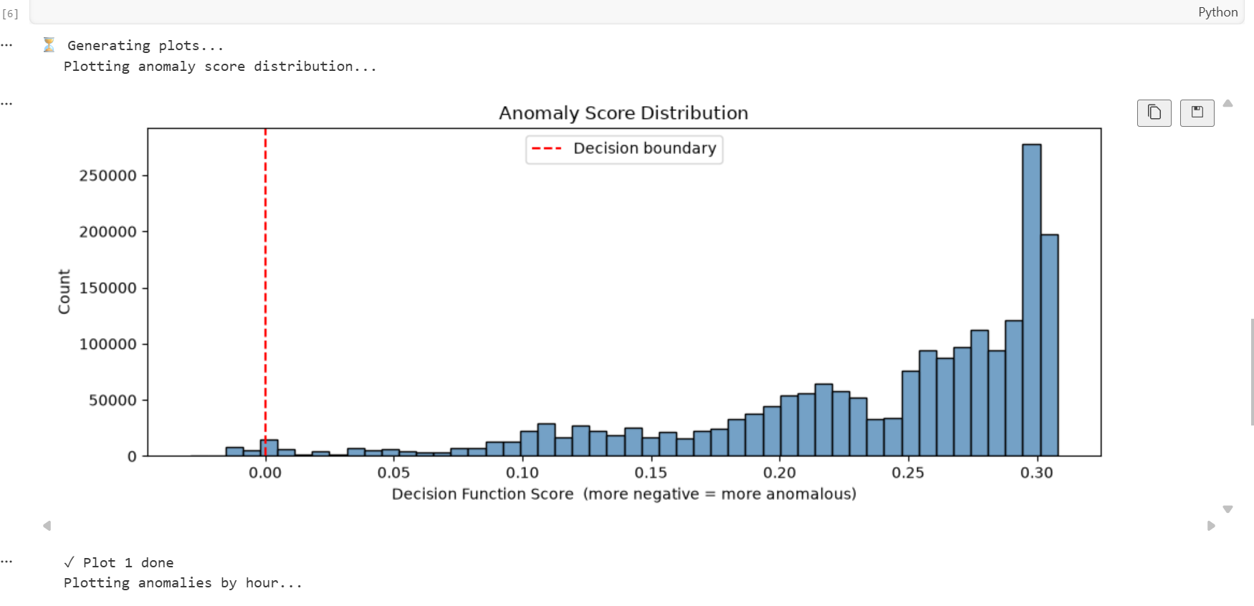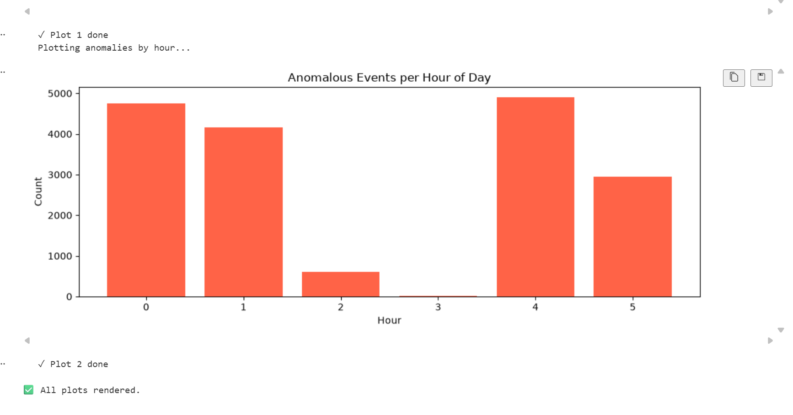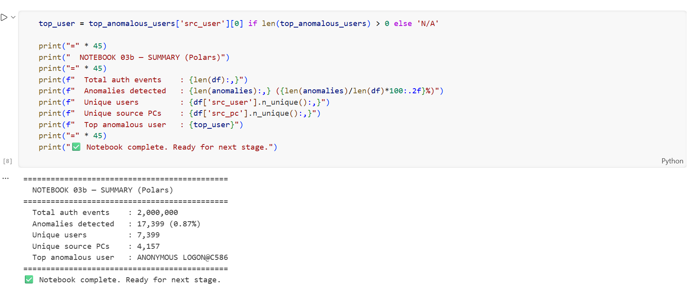
![Anomaly distribution](Exhibit12b_plot.png)
Caption: Plot of anomaly distribution, demonstrating the model’s detection capability.

5. Significance for the “Well Positioned” Prong

This project provides concrete, verifiable evidence that I have already begun executing the hybrid identity anomaly detection research I described. Specifically, I have:

- Built a context‑aware feature engineering pipeline that captures user behavior patterns.
- Trained and evaluated an unsupervised anomaly detector on 500,000 real authentication events.
- Produced a reusable model that can be deployed in a SIEM or identity analytics tool.
- Published the code and artifacts openly to benefit the broader security community.

Together with the RegMap compliance framework (Exhibit 11) and my publication record, this project further demonstrates that I am well positioned to carry out the proposed endeavor without employer sponsorship.

Date: June 25, 2026
Prepared by: Samuel Gbli Tetteh

